Queues with ORM Stack

Contents

1. Introduction 3
2. Workflow diagram to deploy the stack 3
3. Create stack for the Queue on “Default Domain” 4
4. Plan the Job 7
5. Apply the Job 8
6. Verify in the Console 9
7. Destroy the stack 10

Introduction

In the context of Oracle Cloud Infrastructure (OCI), a queue refers to the Oracle Cloud Infrastructure Queue service, which is a fully managed message queue service provided by Oracle. It enables you to send, store, and receive messages between different components of your applications or microservices.

The OCI Queue service offers reliable message delivery, ensuring that messages are persisted and retained until they are explicitly acknowledged. It supports both point-to-point and publish-subscribe messaging patterns.

Workflow diagram to deploy the stack
Below diagram shows how the Terraform Artifact are applied in the OCI. While creating a ORM stack, using terraform deliverables Init, Plan and Apply is the flow to provision the resource in the OCI. We can have the deliverables in any of below.
- GitLab/GitHub Repo
- Bitbucket
- Can be in folder/.zip in the local disk
- Object Storage Bucket
- Can be in compartment
- Oracle provided Template


Create stack for the Queue on “Default Domain”

Go to OCI Console Developer Services Resource Manager Stacks select the compartment Create Stack

My Configuration Folder Browse Select the “queue” folder that contains the terraform Upload

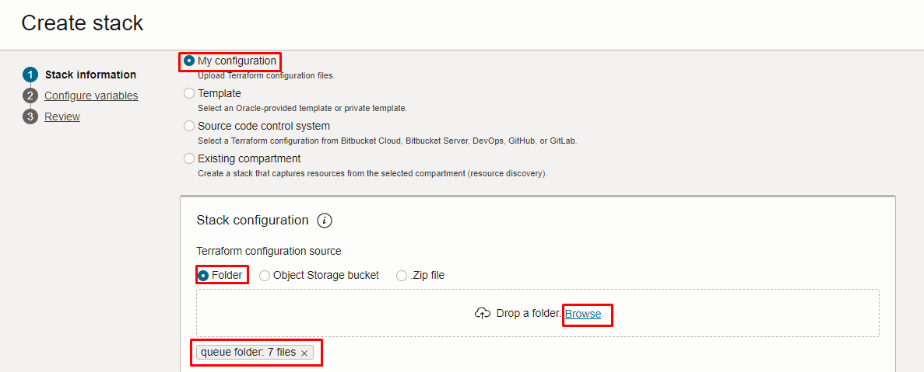
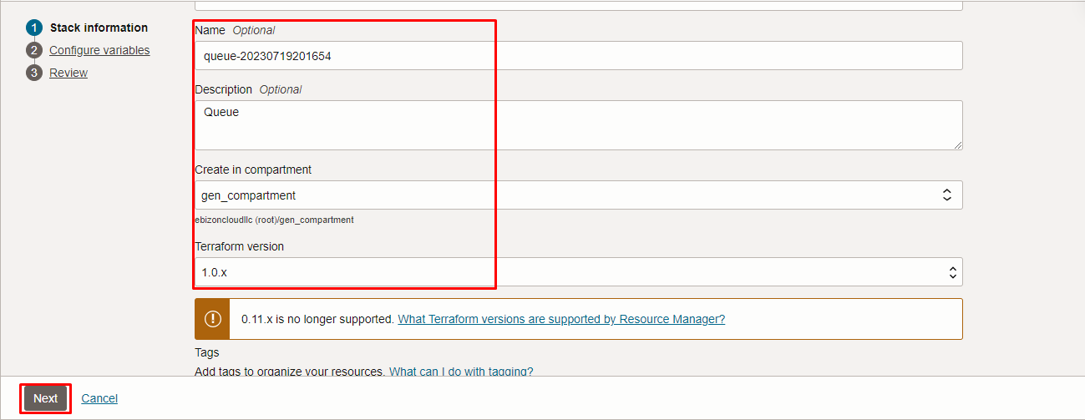

Click “NEXT”

Select the parameters as per the below screen,
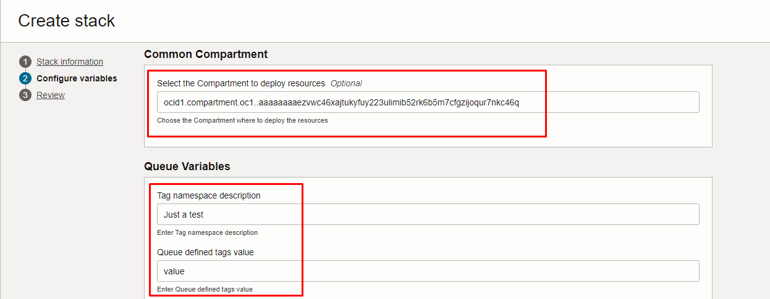
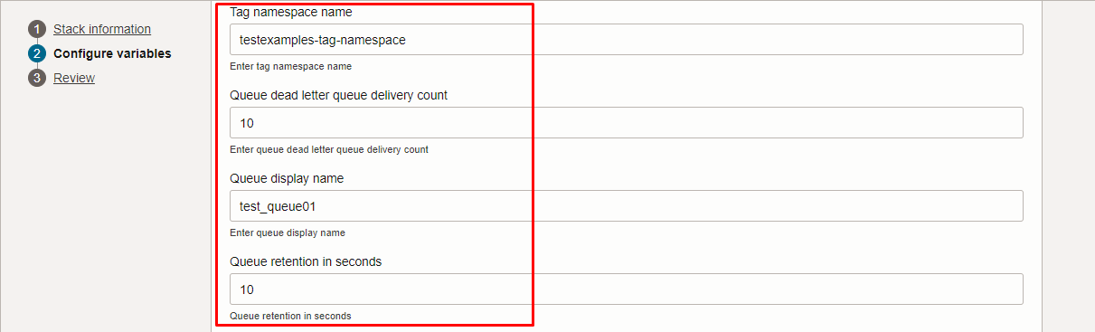
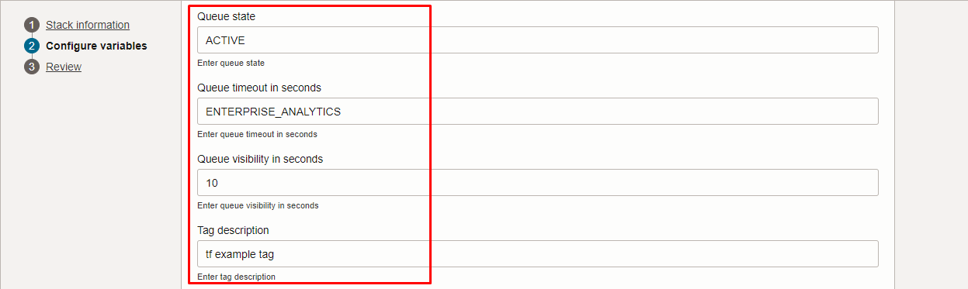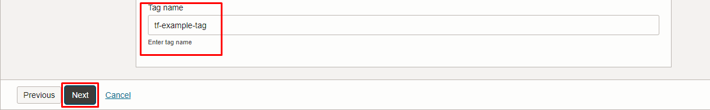

Click “NEXT” Click “CREATE”

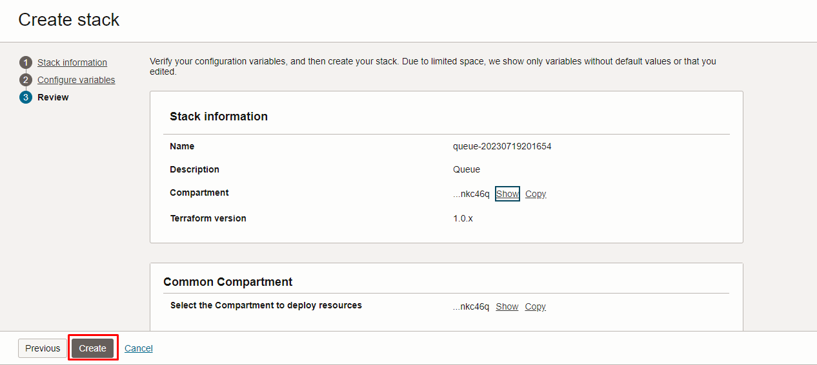

Plan the Job

Click the “Plan”

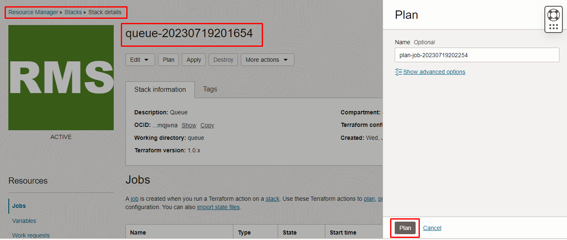

Verify the Plan is successful.

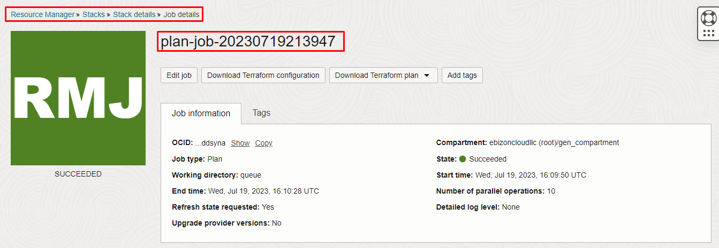
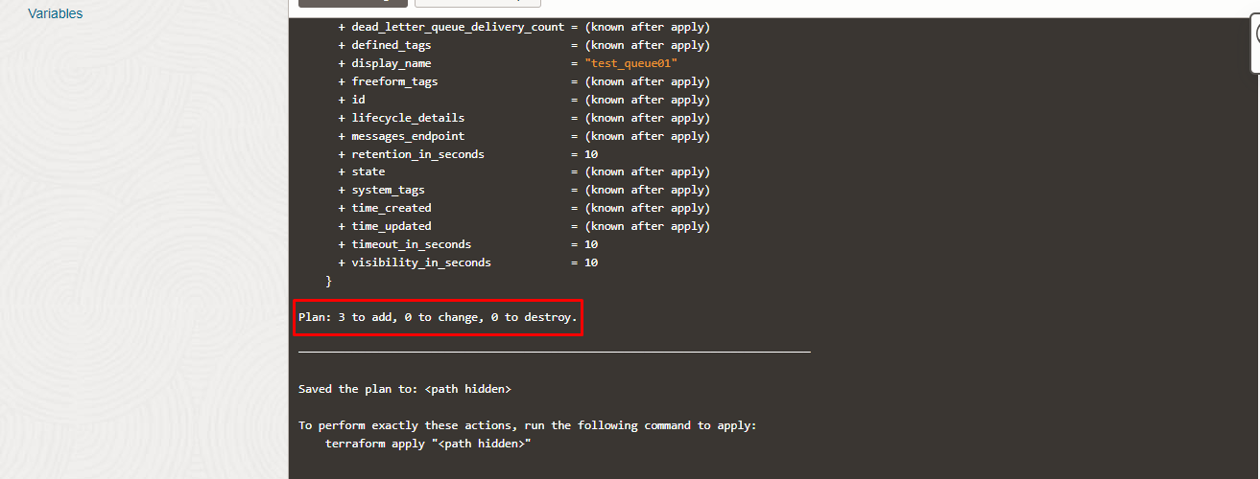

Apply the Job

Once the “plan” is success, now click “Apply”

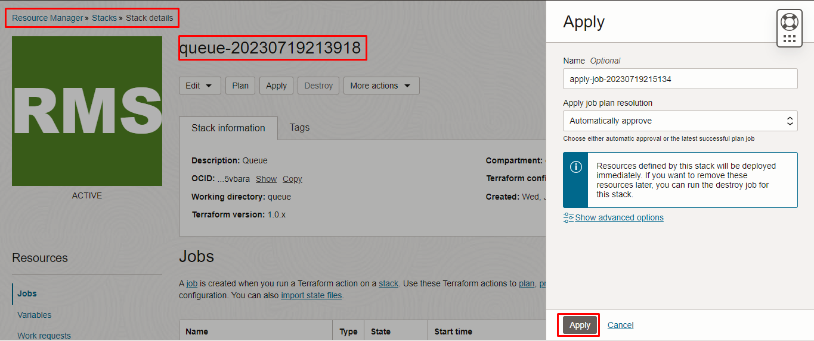

Verify the Apply is successful.

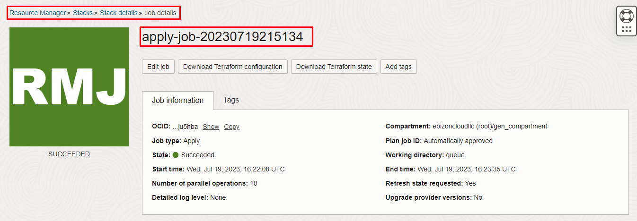

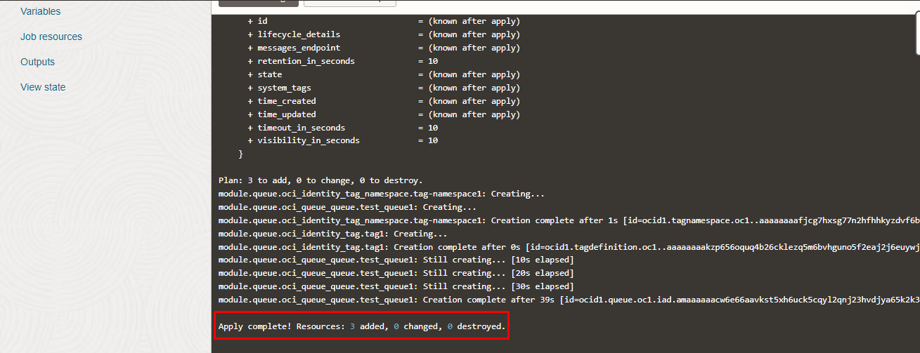

Verify in the Console

Go to OCI Console Developer Services Queues

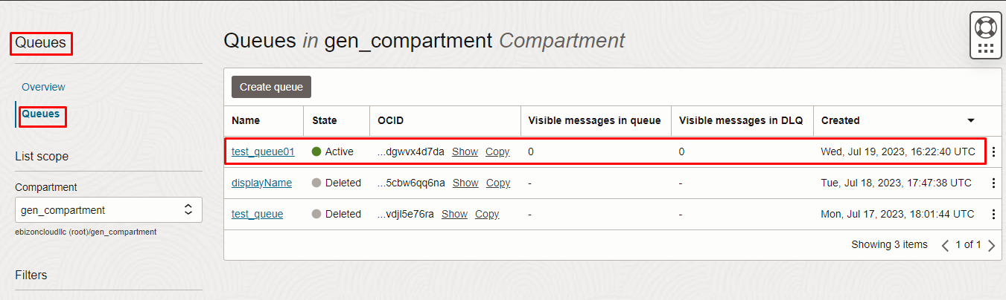
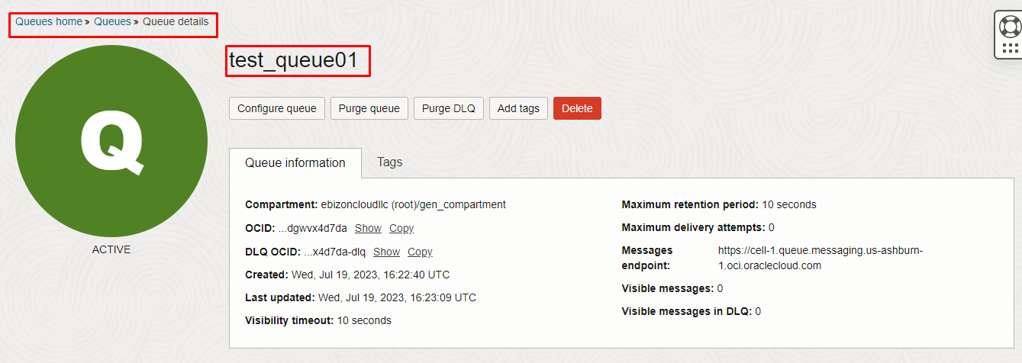

Destroy the stack

Create a destroy job in Resource Manager to release resources associated with a stack and clean up the tenancy. Once destroyed data cannot be recovered from resources.

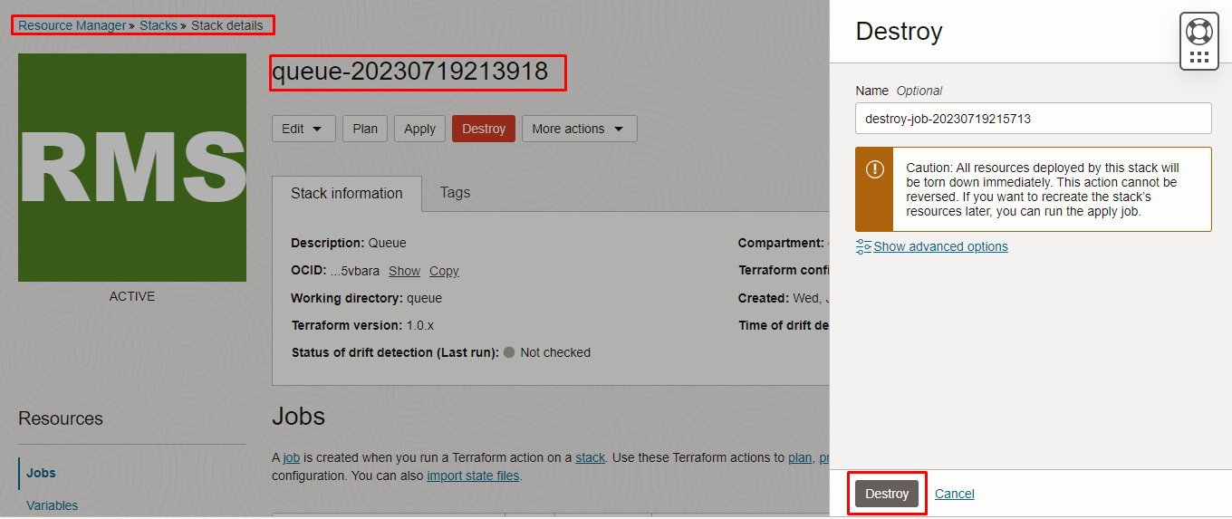

# END #

